Superset of FSM

FSM is regular language, small subset of Turing Machine

Banker’s/Philosopher’s Paradigm

System resource < enough that’s needed by all

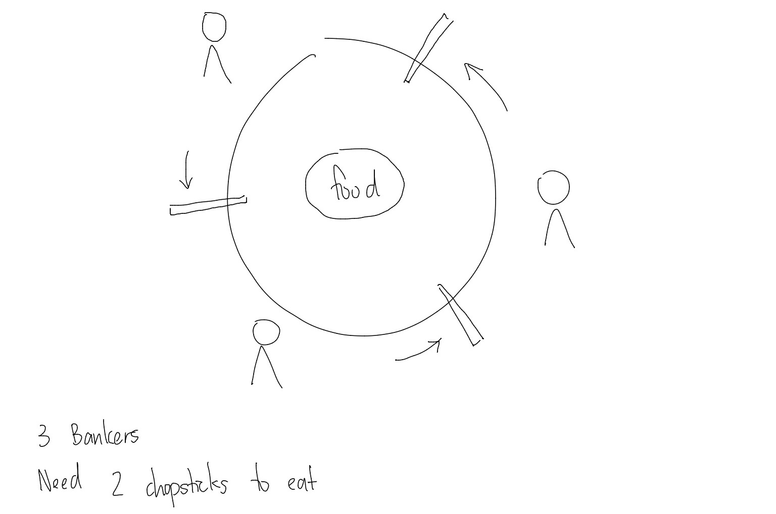

* 1: irrelevant, lack, no one can continue
* 2 or 3: deadlock
  + solvable by smart scheduling
  + always in this irl
  + algorithm to resolve DL
  + priority queue
    - weakest
    - oldest
    - lightest weight
  + fairness: time-sharing
    - set number of bites, next in queue
* 4+: no deadlock
  + nvr have this situation irl

EX: 3 ppl in sea, 1 boat leaking, sharks around, 1 person should go

* 2->1 fairness
  + random choice: set up rule everyone must agree with, best/humane
* CS: boolean logic, 1/0
* Pearl: probability/statistics foundation of CS

FSM

* state given condition/even next state
* no concept of count of resources

Petri-net

* not UML but still must learn
* transition is AND gate
* firing: number tokens in input place
* # of tokens >= # edges/links

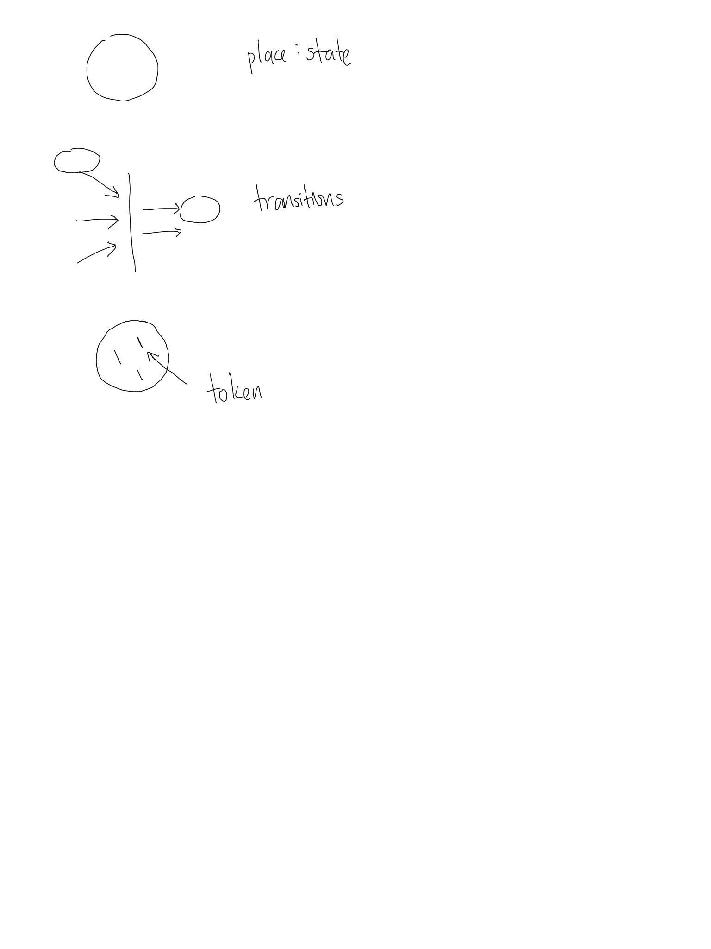

EX: Banker’s Paradigm

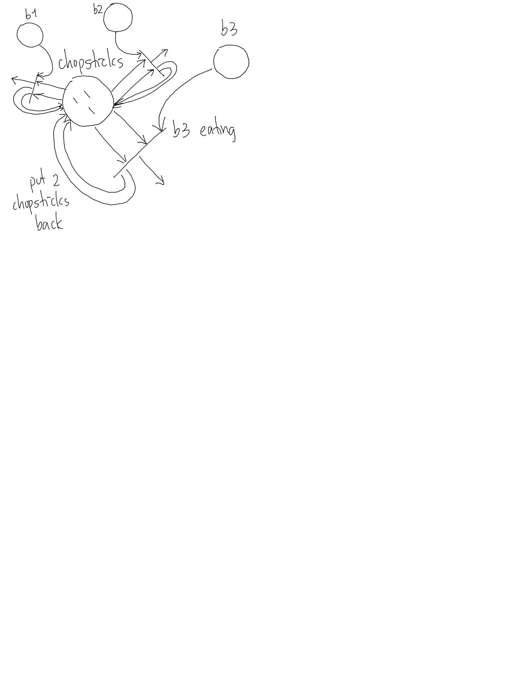

EX: Student Admission

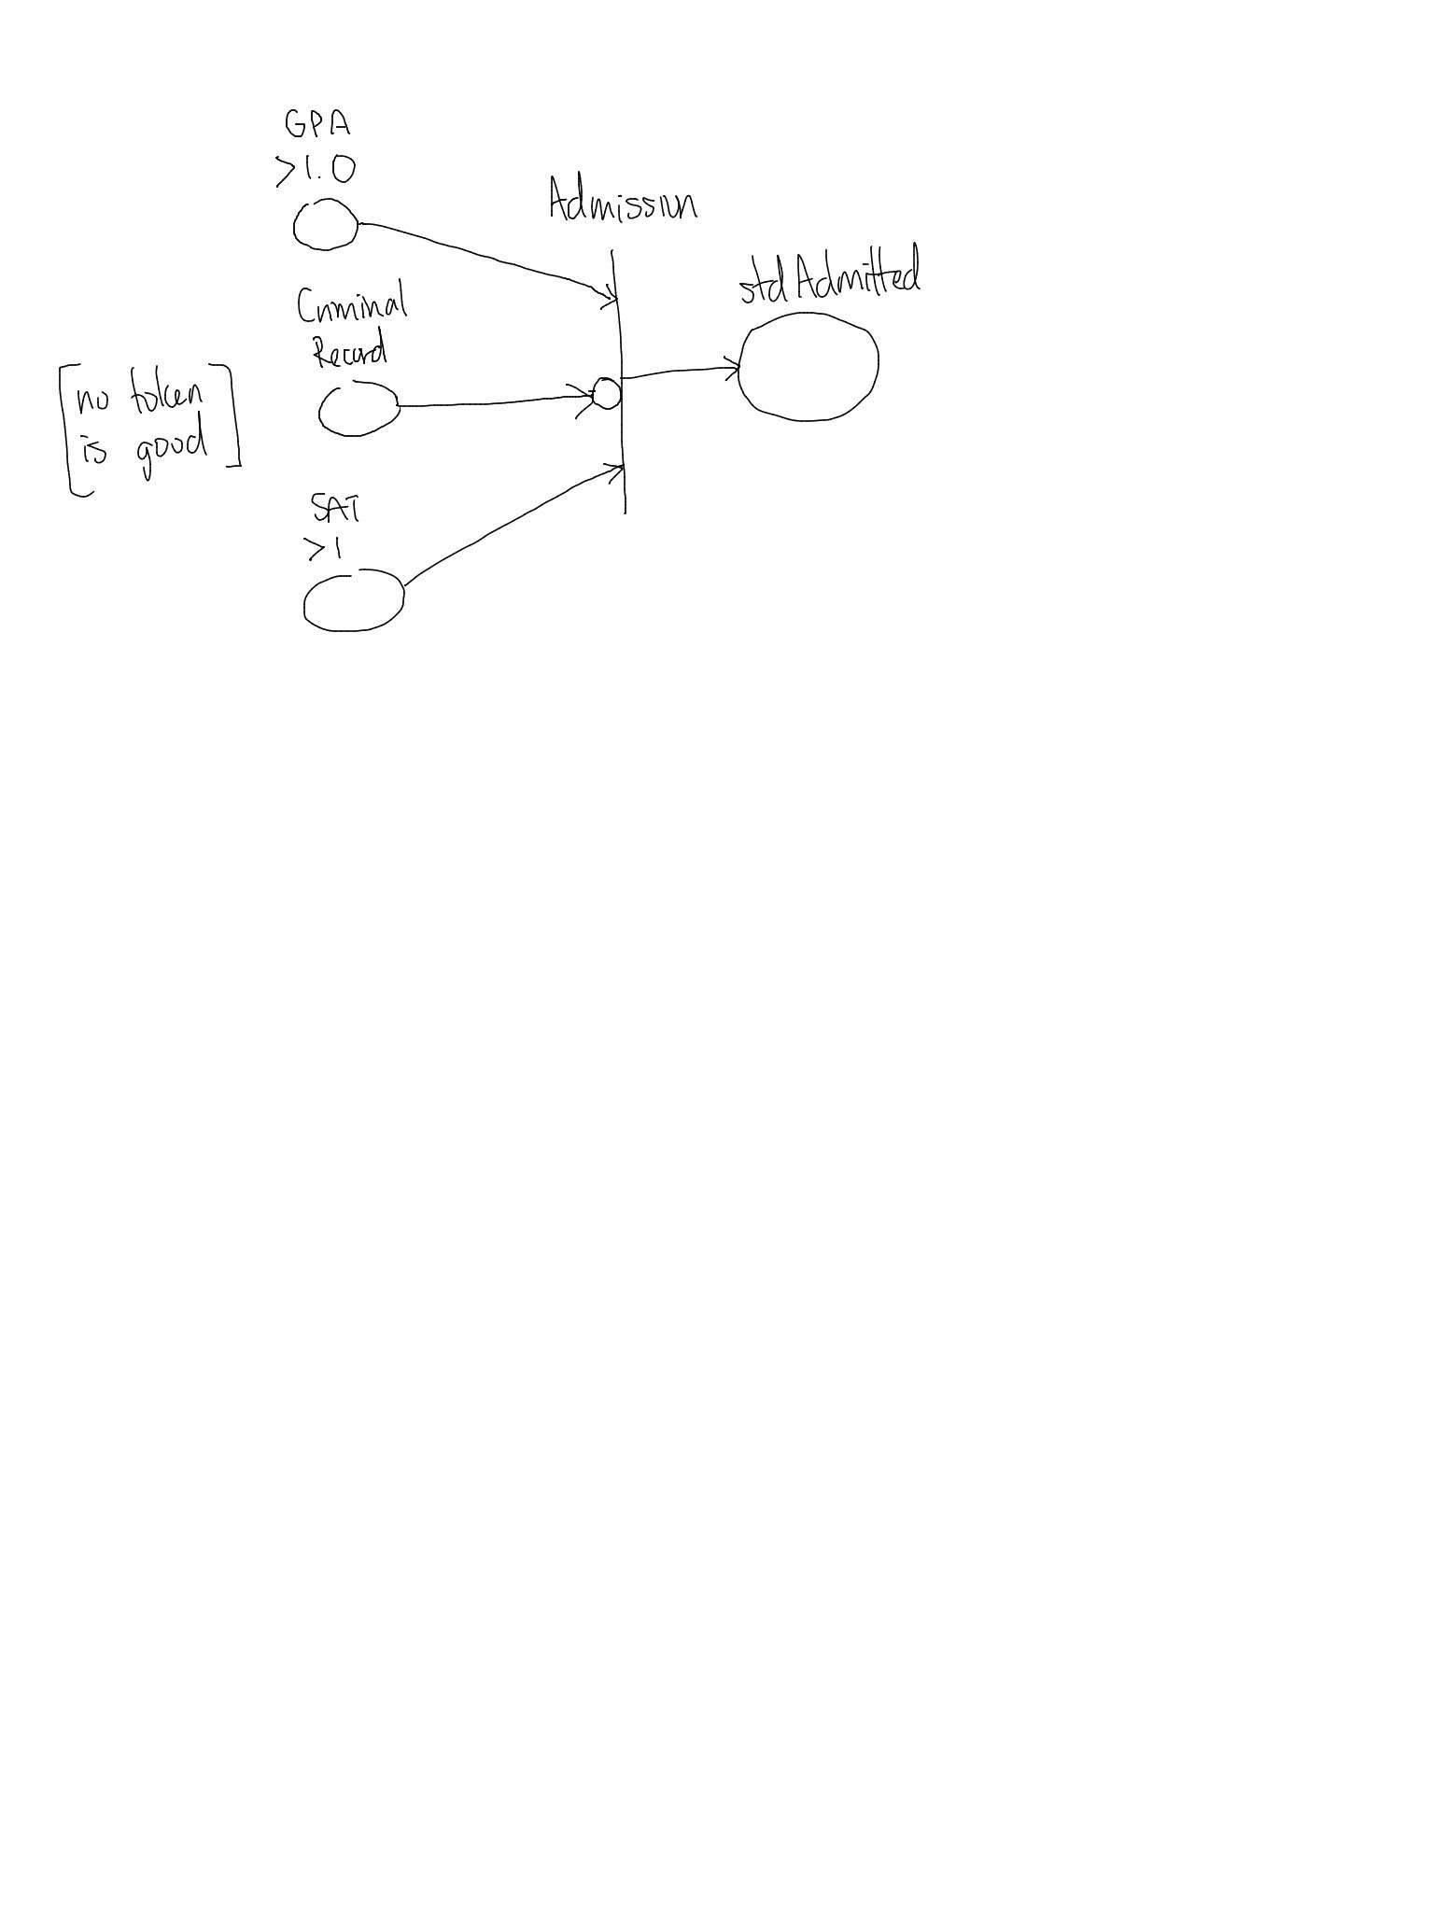

EX: Library

* new book must be registered before shelving
* to check out book, std must have id
* book returned later than deadline will be fined
* book returned put back onshelf
* book not returned in year will be reported to police
* bk checked out >100 times put on sale
* any student w police report not allowed to check out

